Assignment 6

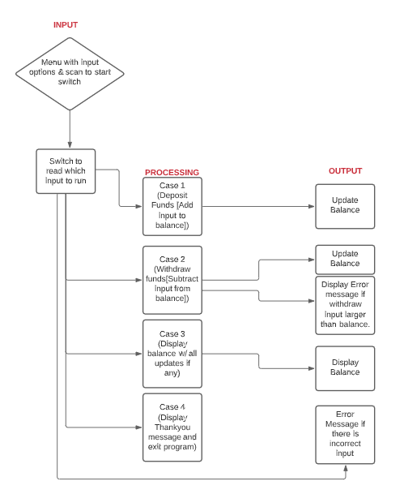

#include <stdio.h>

#include <stdlib.h>

//Katherine Manning

//03/15/21

//COP 1000C

/\*Goal of program: Create working ATM with switch case

ATM has to update balance on every change and exit with thank-You

message. Program needs to use switch case.\*/

//declare balance

double balance = 2000.00;

//begin func

main(){

//declare selection for switch case

int selection;

double deposit, withdraw;

//set up menu for user selection and input

printf("\n----------------------------------------------\n");

printf("\n\nPlease enter an option from this list\n\n");

printf("Input 1 to deposit.\n");

printf("Input 2 to withdraw.\n");

printf("Input 3 to see current balance.\n");

printf("Input 4 to exit.\n");

printf("\n----------------------------------------------\n");

//scan input to start switch case

scanf("%d", &selection);

switch(selection)

{

case 1: //Deposit funds from input

//Begin with print statement to ask for input

printf("Please input your deposit amount : ");

scanf("%lf", &deposit);

//Add input to the balance

balance+=deposit;

//Print out new balance

printf("\nYou are depositing : $%.2lf", deposit);

printf("\nYour total balance will now be : $%.2lf", balance);

//Break to menu

break;

case 2: //Withdraw funds from input

//Begin with print to accept input

printf("Please input how much to withdraw : ");

scanf("%lf", &withdraw);

printf("You wish to withdraw : $%.2lf\n",withdraw);

//Deduct input from balance

/\*Create if statement to output error if

withdraw is large than balance\*/

if (withdraw > balance){

printf("Insufficient funds. Please try again.");

} /\*else for if withdraw is less than balance

output new amount\*/

else{

balance-=withdraw;

printf("Your total balance will now be :$%.2lf", balance);

}

//break to menu

break;

case 3:;//Display current balance

printf("Your current balance is : $%.2lf",balance);

//break to menu

break;

case 4://Exit the program

printf("Thank you for using ATM\n");

//Add pause to display thankyou message

system("pause");

exit(0);

default:/\*Set default to output error for any number

other than 1-4 entered\*/

printf("Incorrect Input. Please try again.");

//break back to menu

break;

}

//make sure function runs on loop till exit

main();

}

PROGRAM OUTPUT EXAMPLES :

Incorrect input option -

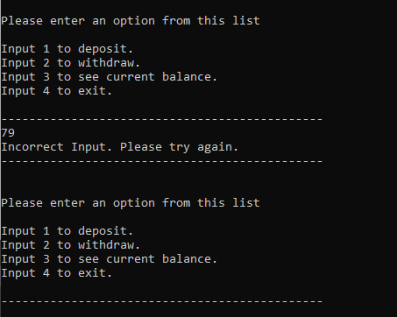

Deposit & Withdrawal –

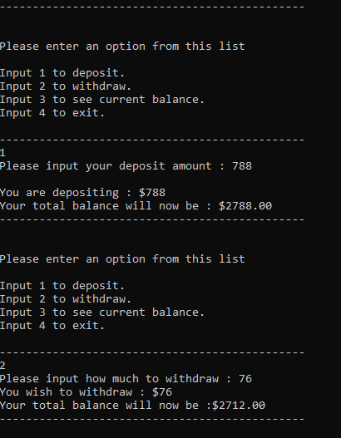

Deposit , Withdrawl, & current balance –

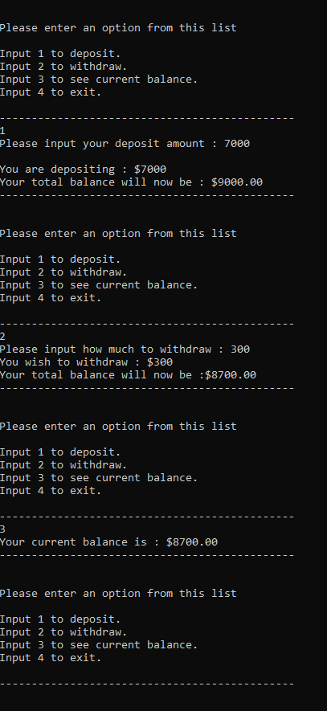

Attempt to withdraw too much –

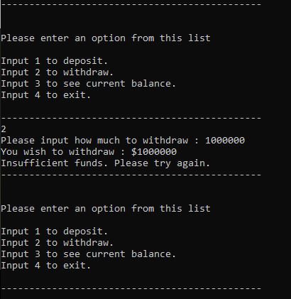

Exit Message and end program –

